LCWU
History of Arts

Submitted by: Faiza Mehmood
Roll No.: 1310
Submitted to: Ma’am Sonia

Victorian Painting

The Victorian period was actually a rich and dynamic era in the arts. Modern art historians have been brought up with the notion that the concept of a narrative in a painting - essentially a painting that tells a story - is either mere illustration or "kitsch." Once this view of painting became the conventional wisdom early in the last century, Victorian Art, so much of which was narrative, was relegated to the basements of museums and even became an object of ridicule. In art history classes around the world, paintings of the Victorian era, whether by Leighton in England or Bouguereau in France, were used as a foil for the Impressionists and early Modern movements. The Victorian era was a sentimental time and there is a fine line between a romantic sentimentality and being overly sweet or saccharine and there were many times when Victorian painters vaulted over that line. However, like any other art form, you only become an effective and intelligent critic of a genre or period when you know it well. And, if your art history courses have taught you to dismiss it out of hand, you will simply be pathologically unable to make intelligent distinctions or draw proper conclusions.
For most of the reign of Queen Victoria, the Royal Academy of Arts led the British art world. Two of its director were also directors of the recently establish National Gallery. In 1869, the Academy moved to its current home at Burlington House in London’s Piccadilly. Here the public crowded the annual summer exhibition and the winter loan exhibition of work by Old Masters and British Artists including Sir Edwin Landseer, known for his animal paintings, and High Victorian Classicist Sir Edward Ponyter and Frederic, Lord Leighton.

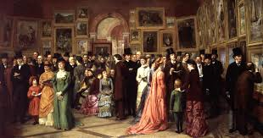
The work of art deposited with the Royal Academy by each member elected to full Academician status present a vivid record of contemporary taste. The exhibition offers the opportunity to view nearly 80 Victorian paintings and sculptures from the Permanent Collection and celebrates the artist and the subjects so lauded in their day. These ranges from idealized nudes and scene from mythology, biblical subjects, and genre scenes illustrating contemporary moral issues, to costume portraits, the search for the exotic and landscapes and seascapes. The artists who created these work include Edwin Austin Abbey, Sir Lawrance Alma-Tadema, William Powell Frith, David Roberts and George Frederic Watls.

Subject of painting:
The subject of their paintings are as follow:
- Fairy painting
- Land and seascape
- Portraiture
- Portrait miniature
- The Pre-Raphaelites
- The classical revival
- The aesthetes and decadents
- Orientalists.

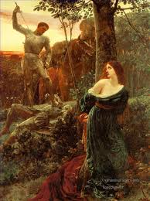

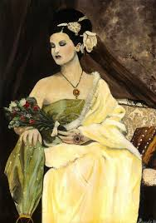

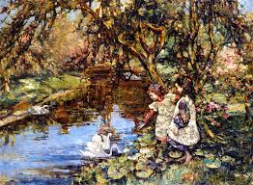

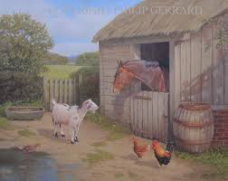

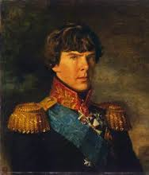

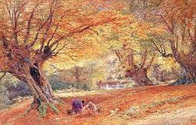

Victorian Neoclassicism was a British style of historical painting inspired by the art and architecture of Classical Greece and Rome.
In the 19th century, an increasing number of Europeans made the "Grand Tour" to Mediterranean lands. There was a great popular interest in the region's ancient ruins and exotic cultures, and this interest fuelled the rise of Classicism in Britain, and orientalis painting, which was mostly centered in continental Europe.
The Classicists were closely associated with the Pre-Raphaelite Artists , many of them being influenced by both styles to one degree or another. Both movements were highly romantic and were inspired by similar historical and mythological theme-- the key distinction being that the Classicists embodied the rigid Academic standards of painting, while the Pre-Raphaelite Brotherhood was initially formed as a rebellion against those same standards.
Lawrence Alma Tadema and Frederic Leighton were the leading Classicists, and indeed in their lifetimes their paintings were considered by many to be the finest of their generation.

